ResourceMananger

**Features**

Resourcemanager is an application which helps users, to save Resources and keep track of the activities done for those resources. E.g. Learning Resources, other files like Music or videos.

This application works as a bookmarking tool for digital resources which saves metadata for Resources. This application helps users, to bookmark the Resources; the user may not be able to immediately refer. The user can save the Resource information and Location in this application with a priority assigned, which the User can refer later and check those Resources information. As the user goes through those Resources, he can add Activities against that Resource, with simple notes which can be kept as an Activity Log.

A user may see good tutorial for Angular.js or Ember.js, which he cannot completely read at that time, or it may not be of high priority at that time. He can save that information in ResourceManager application and set a Priority for that. Later if he wants to refer that, he can take the metadata from the application and read the complete content.

Users can Login/Register to the system and manage the Resources and related information saved by them

Entities

1. Location

Logged in users can manage Locations, the locations where the Resources reside.

1. Resources

Users can manage the various Resources through the system. Users can prioritize the Resources from 1 to 10. Resources can be saved at Locations, available to the Logged in User.

1. Activities

Users can have activities against the Resources. Notes can be saved for these activities which can further viewed by the Users as Activity log.

**Solution Structure**

The solution has the following structure

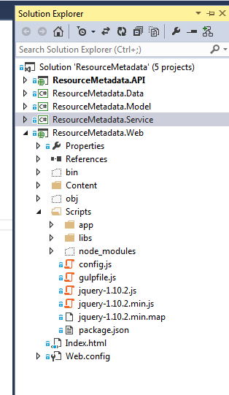

1. ResourceMetadata.API - Provides the REST API to which the Client applications will communicate.
2. ResourceMetadata.Data - This is the Application Data Layer.
3. ResourceMetadata.Model - Provides the Application Domain Model.
4. ResourceMetadata.Service - This is the Service Layer for the application.
5. ResourceMetadata.Web - Client side application

**Screen Shots**

Login screen

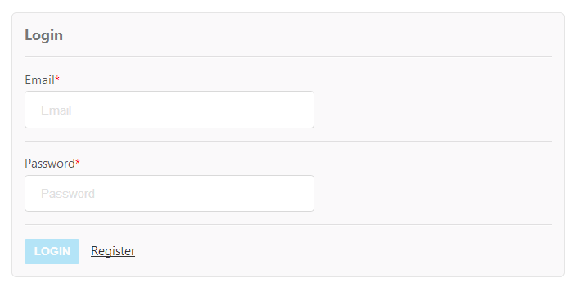

Registration screen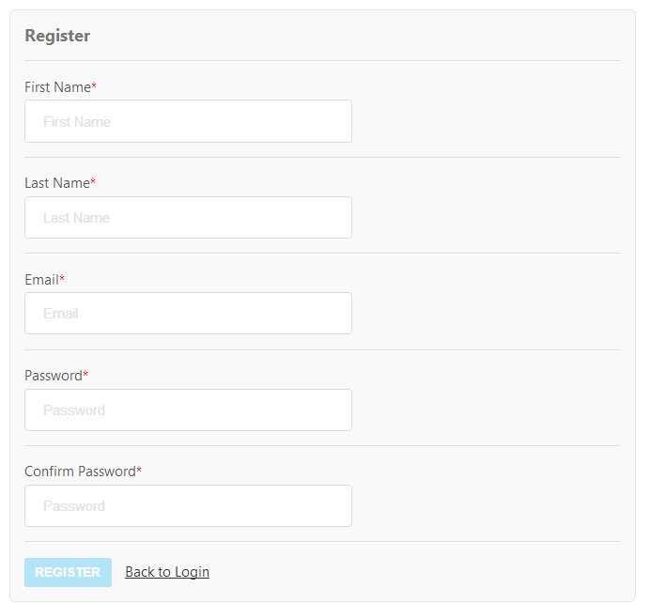

Home screen

The Home screen will display to 5 Resources saved by the logged in User in Descending Order of the Priority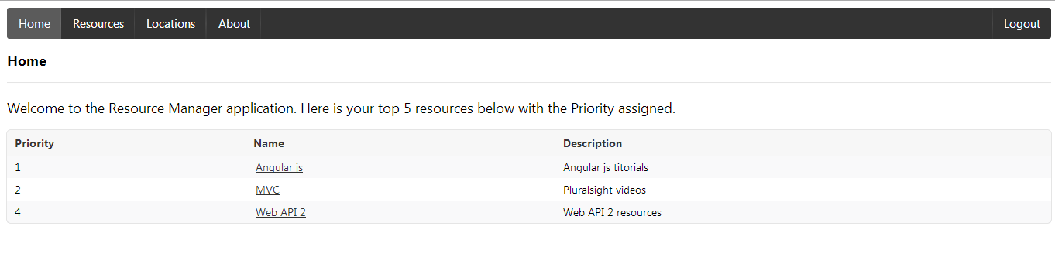

Locations screen

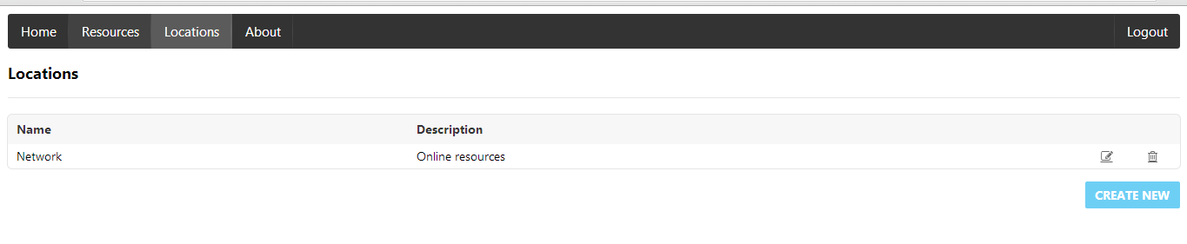

Add Location screen

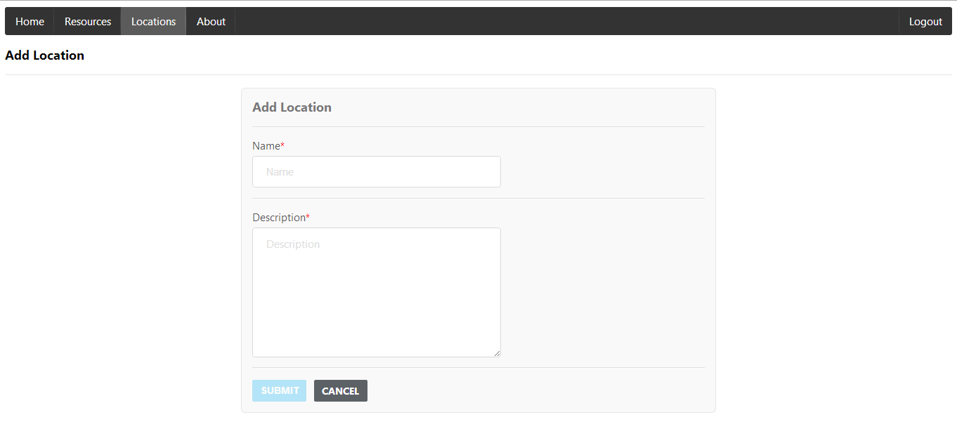

Edit Location screen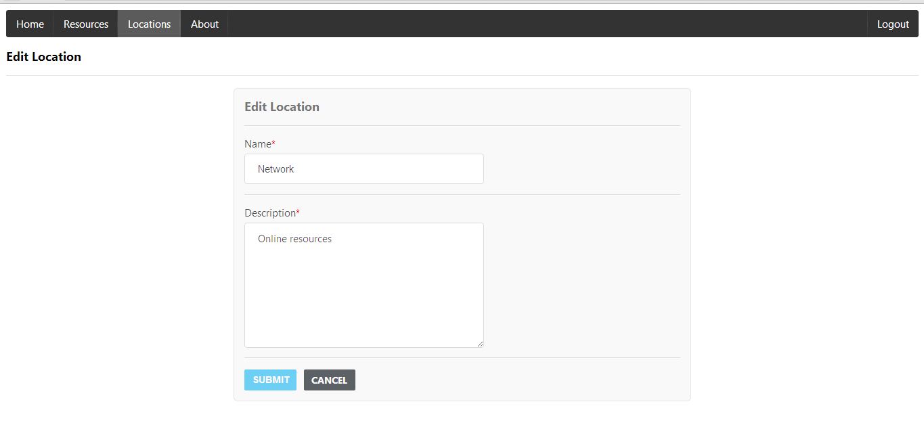

Resources screen

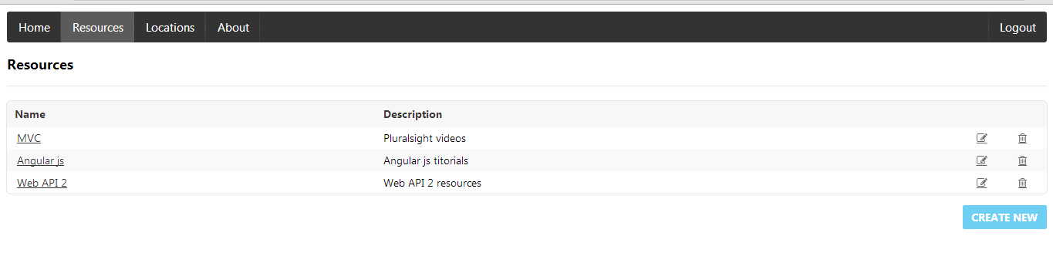

Add Resource screen

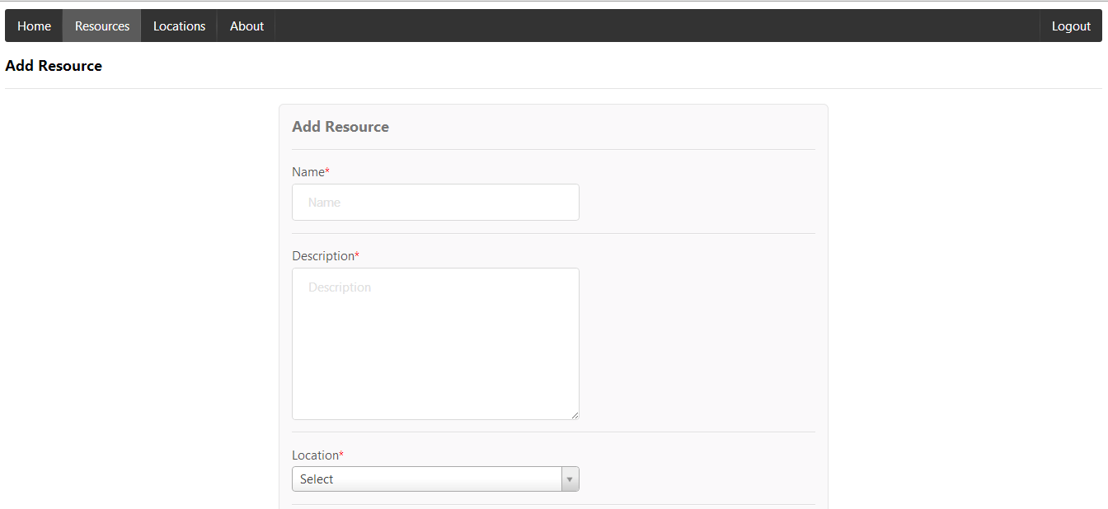

Edit Resource screen

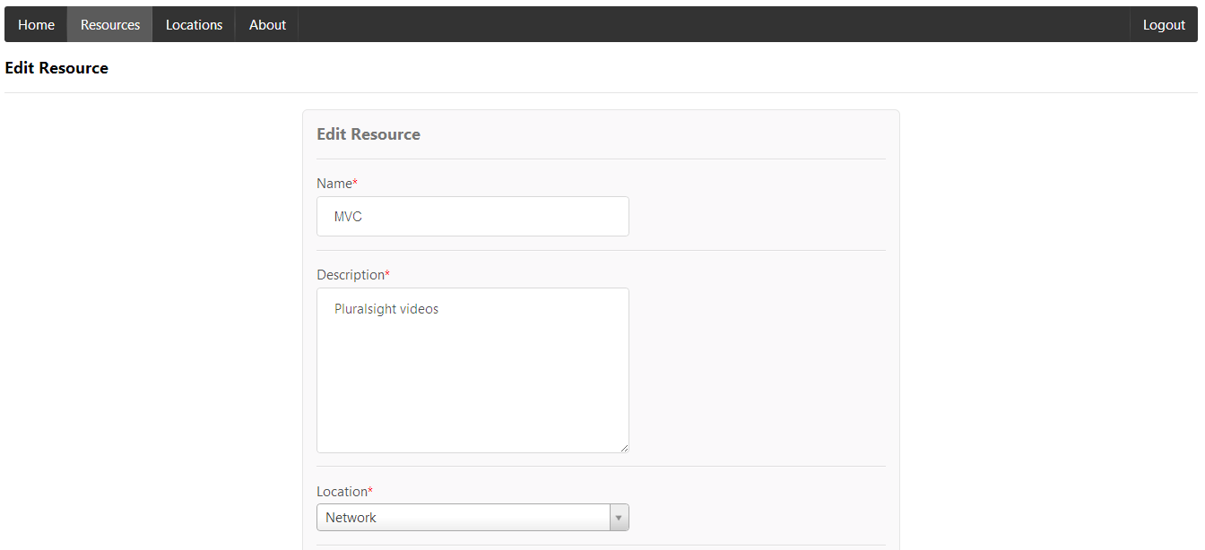

Resource Details screen

Users can view Details of the Resource and activities done against the Resource so far in this screen. The notes for the Activities can be shown from a popup displayed which clicking the activity title.

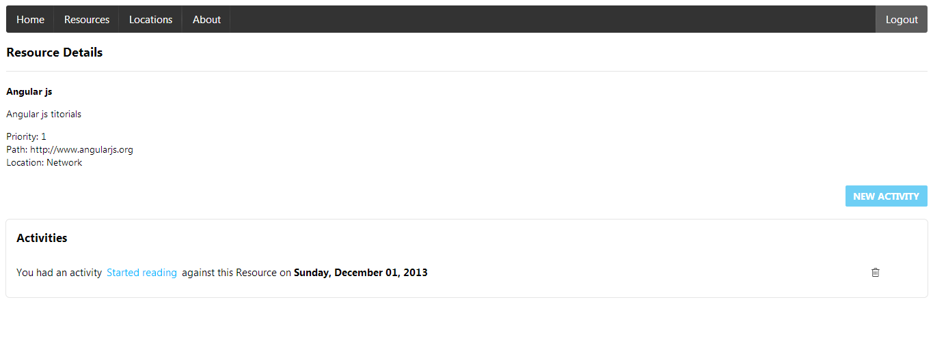

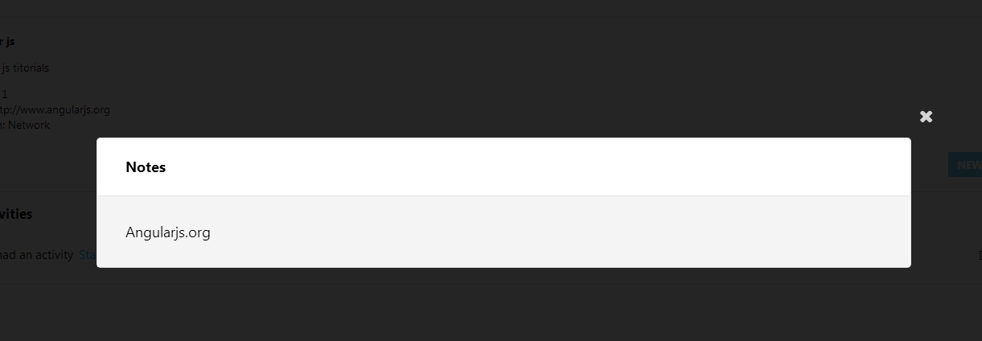

Add Activity screen

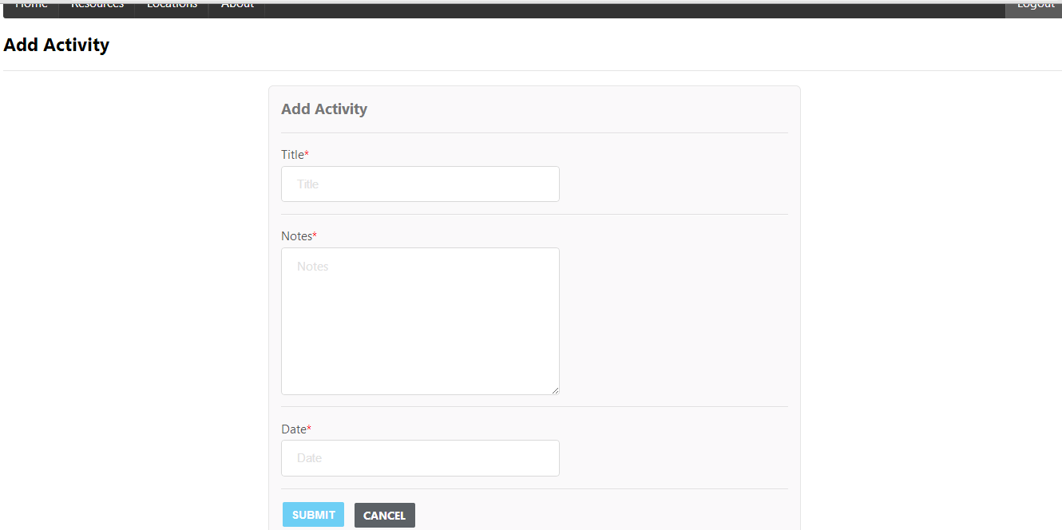

**Known Issues**

1. Only basic validations are provided now.
2. Menu navigation pre-selection while sharing url
3. Improve user session expiration handling.
4. Need to improve security features
5. Improve css features
6. Confirmation popups uses basic javscript. These have to be changed to css.

**Technical features to be implemented**

1. Enable HTML5 routing
2. Include Request/Response interceptors for better error handling and status display

**Technologies/Frameworks Used**

1. **Persistence/ORM** : EntityFramework Code first
2. **Server side** : ASP.Net
3. **Web Framework**: ASP.Net MVC5- WebAPI2
4. **Data Mappers** : AutoMapper
5. **IoC**: Autofac
6. **Client side**: Angular.js, jQuery, Semantic UI